**Report Analysis For The Retail Store**

**Introduction**  
This report analyzes the retail store’s monthly sales performance from January 2023 to January 2024, focusing on identifying trends, sales by product category and identifying trends.

I accessed the business performance and I came up with the month with the highest sales, top selling product category and how the store can make more sales than it has already.

**Objective**  
The objective of this report is to evaluate the retail store’s monthly sales performance from January 2023 to January 2024, identify seasonal trends and periods of peak or low demand, and determine the top-performing product categories.

**Data Source**

I got my dataset from Kaggle.com

**Data Cleaning**

When I got the datasets, I checked for blanks, missing cells and duplicates using conditional formatting but there were none. Then I added a new column which is the monthly column which I extracted from the date column on the dataset which is what I worked with on the analysis.

**Analysis**

These are the key findings I got from the analysis

Product Category with the highest sales wasElectronics

Highest Sales Month wasMay 2023 cause the store made ₦ 53,150 from sales.

Lowest Sales Month was January 2024 cause the store made ₦ 1,530 in total sales.

**Trend:** Steady sales all through the year with notable increase in sales in may 2023 but it was mostly steady through the remainder of the year and there was a significant drop in sales in January 2024.

**These are the visuals for the analysis**

**Monthly sales performance**

Sales distribution by product category

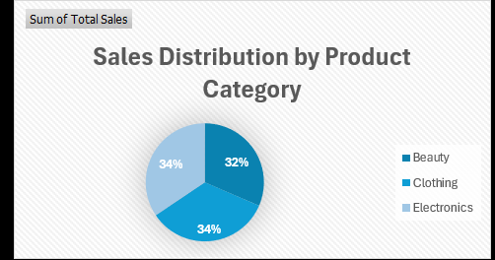

Here, we can see that 34% of products were sold from the electronics category, while the beauty and clothing categories sold 32% of products each.

**Recommendations**

Based on my analysis, I believe the store can make more sales with incentives like buy two and get one free, because it’s will increase sales in products. This should go on for a certain period of time.

I think the store should also create a survey questions and ask the consumers what they love to get but is not on the stores product list, this will engage the consumers more and the store will get to know what they want and I am sure this will definitely increase sales.

**Conclusion**

The store demonstrated strong overall growth in 2023, By strategically planning around seasonal trends, engaging the consumers and building a strong relationship with them, optimizing inventory for top-selling products, sales performance can be further enhanced in the coming year.